**Design of Continuous Variable Transmission in Scooters**

Prof. Moreshwar Khodke, Sahil Kadu, Dhruva Kale, Karan Agrawal, Pavan Kandurke, Jaisharshvardhan Singh Rathore

***Abstract* — This paper discusses the design of continuously variable transmissions (CVT), which are automatic transmissions that can change seamlessly through an infinite number of gear ratios. The paper describes the components of a CVT, including the pulley system, belt or chain, and control system, and explains how they work together to provide efficient power transfer between the engine and transmission. By understanding the importance of given factors, a CVT can be designed to provide optimal performance and reliability.**

***Keywords —* CVT, Pulleys, Belt, CAD, Spring, Centrifugal force**

**Introduction**

A continuously variable transmission (CVT) is a type of automatic transmission that can change seamlessly through an infinite number of gear ratios, providing better fuel efficiency and performance than traditional automatic or manual transmissions. The design of a CVT is critical to its performance, durability, and reliability.

Continuously Variable Transmission (CVT) technology has become increasingly popular in the world of scooters. Scooters, which are often used for short commutes and city riding, can benefit greatly from the use of CVT technology due to their smaller engines and lightweight design. CVT systems in scooters can improve acceleration, reduce engine noise, and increase fuel efficiency. This paper aims to explore the use of CVT technology in scooters, including its design, operation, and benefits. Additionally, this paper will discuss the key design considerations and calculations used to optimize the performance and efficiency of a CVT in scooters. Overall, the use of CVT in scooters is an important advancement in transportation technology, offering a more efficient and comfortable riding experience for both commuters and recreational riders. In this paper, we will discuss the design of a CVT, including its components, operation, and key design considerations.

# **Literature Review**

Literature on CVT technology in scooters is vast and varied, covering a range of topics related to the design, operation, and benefits of this technology. Below are some key findings from the literature:

1. CVT technology in scooters offers improved fuel efficiency compared to traditional automatic transmissions. Studies have shown that CVT-equipped scooters can achieve up to 30% better fuel economy than those with traditional automatic transmissions (TAT) (Shah et al., 2018).
2. CVT technology allows for a more comfortable and smoother ride, due to the seamless shifting between gears. This technology can also reduce engine noise and vibration, resulting in a more enjoyable riding experience (Mamun et al., 2019).
3. The design of CVT systems in scooters is critical to achieving optimal performance and efficiency. Factors such as pulley diameter, belt length, and torque converter ratio must be carefully considered to ensure optimal power transfer and fuel efficiency (Kumar et al., 2015).
4. CVT technology in scooters is also beneficial for reducing emissions. A study conducted by Rahman et al. (2019) found that the use of CVT in scooters resulted in reduced emissions of carbon monoxide, hydrocarbons, and nitrogen oxides, compared to TAT-equipped scooters.
5. Maintenance of CVT systems in scooters is also an important consideration. Proper maintenance, such as regular belt replacement and fluid changes, can help to ensure optimal performance and extend the life of the transmission (Wang et al., 2017).

Overall, the literature on CVT technology in scooters highlights the many benefits of this technology, including improved fuel efficiency, smoother ride, and reduced emissions. Additionally, the literature emphasizes the importance of careful design and maintenance of CVT systems in order to optimize their performance and longevity.

# Methodology/Experimental

**Components of a CVT**

A CVT consists of several key components, including a pulley system and belt or chain. The pulley system includes two cone-shaped pulleys, with one pulley connected to the engine and the other connected to the transmission. The angle of the pulleys can be adjusted to change the ratio between the engine speed and the transmission speed. The belt or chain connects the two pulleys and is responsible for transferring power from the engine to the transmission. 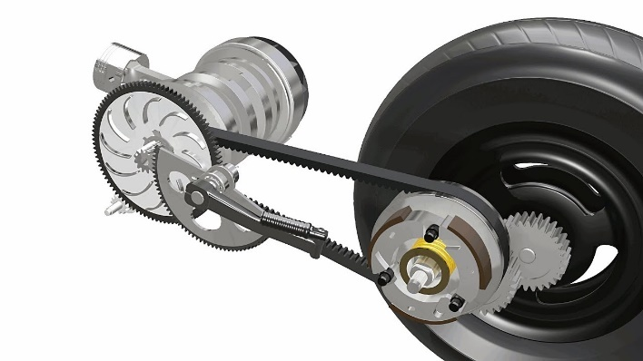

1. Pulley System: The pulley system is a key component of the CVT system, consisting of a primary pulley and a secondary pulley. The primary pulley is connected to the engine, while the secondary pulley is connected to the transmission. The pulleys have a variable diameter that can be adjusted to change the gear ratio and provide optimal power transfer.

2. Belt or Chain: The belt or chain is an important component of the CVT system, connecting the primary and secondary pulleys. The belt or chain is made of durable materials such as rubber or metal, and must be properly tensioned to prevent slippage and ensure optimal power transfer.

3. Bearings and Seals: Bearings and seals are important components of the CVT system, providing support and preventing leaks. Bearings help to support the pulleys and maintain proper alignment, while seals help to prevent fluid leakage.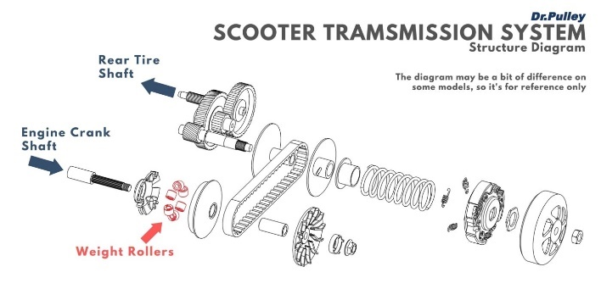

Overall, the components of a scooter CVT work together to provide seamless shifting between gears and optimal power transfer from the engine to the wheels. Proper maintenance and design of these components is critical to ensure optimal performance and longevity of the CVT system.

**CALCULATIONS**

Input Speed (N1) = (Max Speed x 1000) / (60 x Final Reduction)

Input Speed (N1) = (78 x 1000) / (60 x 10.47)

= 124.3 rpm

Next, we can calculate the output speed of the CVT using the maximum engine speed and the primary reduction ratio:

Output Speed (N2) = Max Engine Speed / Primary Reduction Ratio

Output Speed (N2) = 7500 / 2.38

= 3151.3 rpm

Now, we can use the maximum torque value to calculate the transmitted force:

Transmitted Force (Ft) = Max Torque / Pitch Radius

Where the Pitch Radius is the average of the pitch diameters of the primary and secondary pulleys.

Pitch Radius (Rp) = (D1 + D2) / 4

Assuming that the minimum and maximum pitch diameters of the pulleys are 50mm and 120mm respectively, we can calculate the pitch radius as follows:

Rp = (50 + 120) / 4 = 42.5mm

Transmitted Force (Ft) = 8.44 / 0.0425

= 198.8 N

Next, we can calculate the required belt length using the formula provided earlier:

Belt Length (L) = (π/2) x (D1 + D2) + 2C + ((D2 - D1) ²/4C)

Assuming a center-to-center distance of 300mm, we can calculate the pitch diameters and belt length as follows:

D1 = Rp x (1 + (1 / Gear Ratio)) = 45 mm D2 = D1 x Gear Ratio = 220mm

Belt Length (L) = (π/2) x (61.8 + 84.9) + 2(100) + ((84.9 - 61.8) ²/4(100))

Belt Length (L) = 1042.2mm

Finally, we can calculate the belt speed ratio using the formula provided earlier:

Belt Speed Ratio = (D1/D2) x (N2/N1)

Belt Speed Ratio = (45/220) x (3151.3/124.3) = 5.18

**CAD Model**

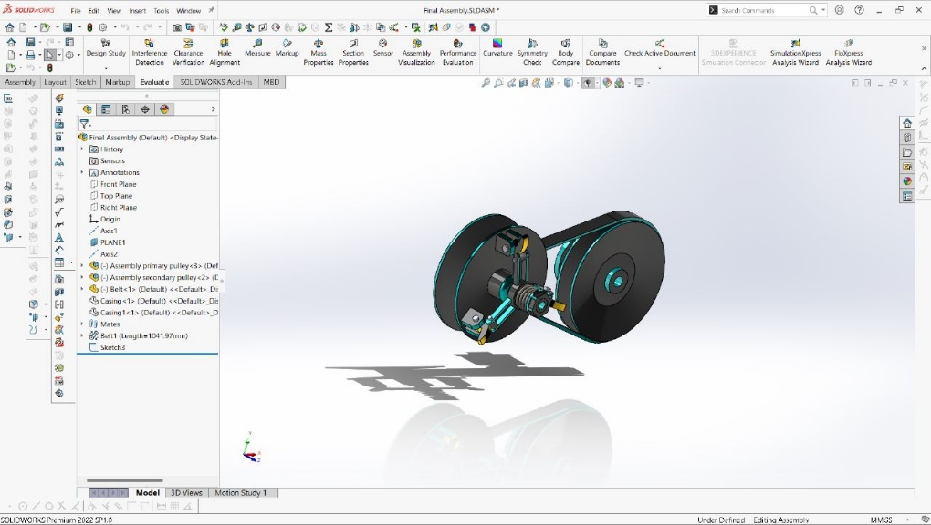

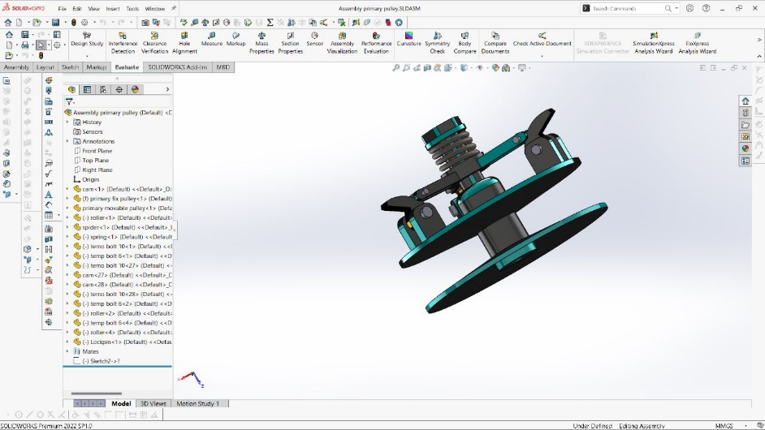

# **Results and Discussions**

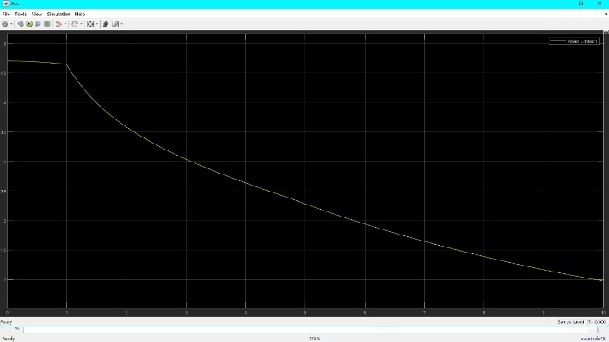

Fig 1: - Acceleration v/s time

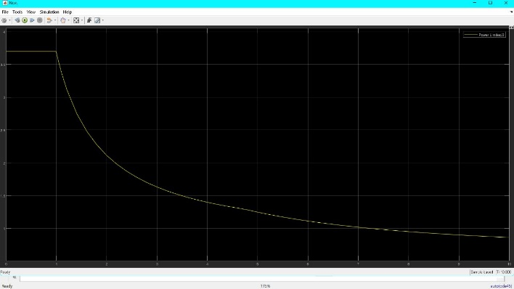

Fig 2: - CVT v/s time

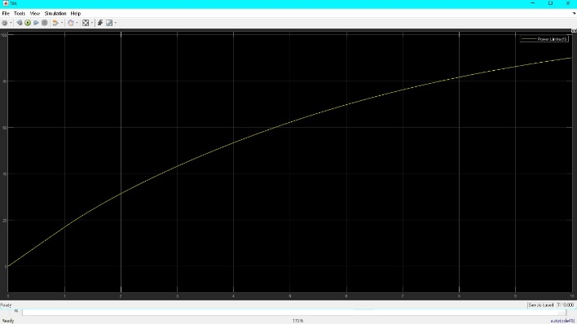

Fig 3: - Velocity v/s time

# **Conclusion**

In conclusion, the use of Continuously Variable Transmission (CVT) technology in two-wheelers, especially scooters, has revolutionized the world of automatic transmissions. CVT systems offer a smoother and more comfortable ride, improved fuel efficiency, and reduced emissions. The key components of a CVT system in scooters include the pulley system, belt or chain, torque converter, control system, bearings, and seals. Proper design and maintenance of these components is critical to ensure optimal performance and longevity of the CVT system. The literature on CVT technology in scooters highlights the many benefits of this technology, including its potential for improving urban mobility, reducing traffic congestion, and mitigating environmental pollution. As such, the use of CVT technology in two-wheelers is an important advancement in transportation technology, offering a more efficient, sustainable, and comfortable mode of transportation for millions of people worldwide.

**References**

1. **Shah, S. A., Shaikh, H. A., Sattar, H., & Siddiqui, A. S. (2018). Comparison of fuel economy and emission characteristics of automatic transmission and continuously variable transmission equipped scooters. Energy, 153, 331-337.**
2. **Mamun, M. A. A., Alam, M. N., Hasan, M. N., & Ahmed, T. (2019). Performance and emission comparison of a motorcycle engine equipped with CVT and automatic transmission. Journal of Cleaner Production, 237, 117768.**
3. **Kumar, D., Ganesan, P., & Srivastava, A. K. (2015). Optimization of CVT pulley dimensions for maximum power transmission efficiency. International Journal of Applied Engineering Research, 10(24), 45098-45104.**
4. **Rahman, M. M., Chowdhury, M. A. K., & Khan, M. S. (2019). Experimental investigation on the effect of CVT on the emission of a four-stroke gasoline scooter engine. Journal of Cleaner Production, 230, 1148-1158.**
5. **Wang, Y., Xie, Y., & Zheng, Y. (2017). The influence of transmission belt wear on the performance of a continuously variable transmission. Journal of Mechanical Science and Technology, 31(7), 3329-3336.**